Project Name:
Business Sales Analysis Using SQL
Student Name:
Rutuja Dhondiram Patil
Tool Used:
PostgreSQL, pgAdmin
Project Description:
This project analyzes business sales data using SQL queries to understand customer behavior, product performance, city-wise sales, and time-based sales trends.
Problem Statement:
The goal of this project is to analyze customer orders, product performance, and sales trends using SQL to generate meaningful business insights.

1.Introduction :
This project focuses on analyzing business sales data using SQL in PostgreSQL.
The dataset contains three main tables: customers, products, and orders.
Using SQL queries such as JOIN, GROUP BY, HAVING, Window Functions, and Aggregations, the project extracts meaningful insights from the data.
The analysis focuses on:
- Customer purchasing behavior
- Product sales performance
- City-wise revenue trends
- Monthly sales patterns
- Advanced analytics using window functions
This project demonstrates how SQL can be used for business intelligence and data analysis.
2.Database Design
To store the business sales data, three tables were created in PostgreSQL: customers, products, and orders. The following SQL queries were used to create these tables.

Customer table
This table stores information about customers including their ID, name, and city.
Column | Description
customer_id | Unique ID of customer
customer_name | Name of customer
city | City where customer lives
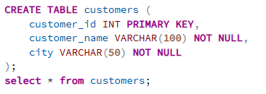
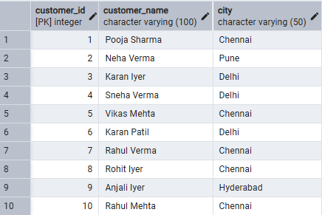
Note: Only the first few rows of the dataset are shown for preview.

Products Table
This table stores information about products.
Column Name | Data Type | Description
product_id | INT | Unique product identifier
product_name | VARCHAR | Product name
category | VARCHAR | Product category
brand | VARCHAR | Brand name
price | DECIMAL | Product price
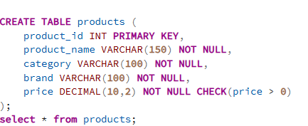
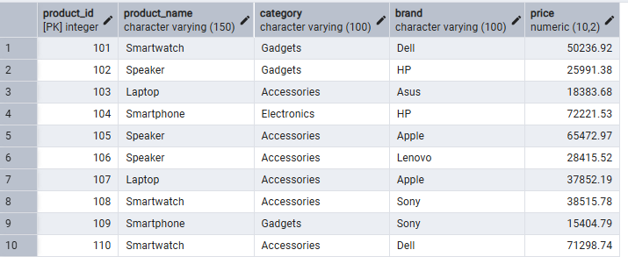
Note: Only the first few rows of the dataset are shown for preview.

Orders Table
This table records all purchase transactions.
Column Name | Data Type | Description
order_id | INT | Unique order identifier
customer_id | INT | Customer placing the order
product_id | INT | Product purchased
order_date | DATE | Date of order
sales | DECIMAL | Sales amount
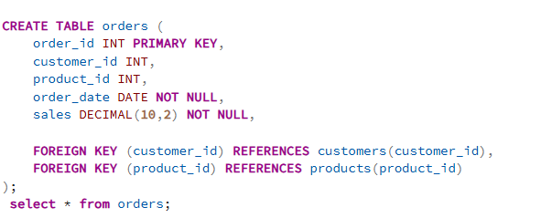
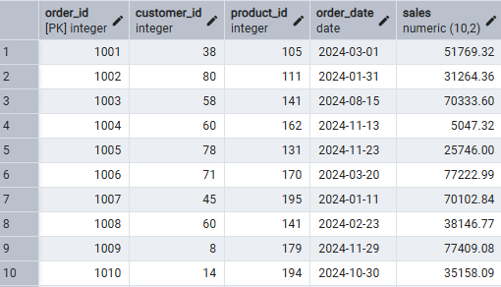
Note: Only the first few rows of the dataset are shown for preview.

3.Basic Business Metrics
This section focuses on key metrics that help understand overall business performance.
- Total Number of Orders
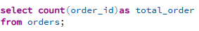
This query calculates the total number of orders placed in the dataset.
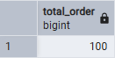

- Total revenue generated.
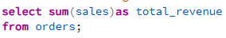
This query calculates the total revenue generated from all orders.
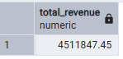

- Total number of customers who placed orders.
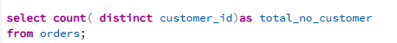
This query counts the number of unique customers who made purchases.
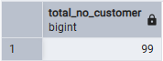

- Average order value.
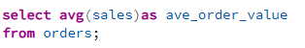
This query calculates the average value of each order.
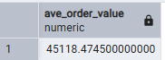
4. Customer Analysis
Customer analysis helps businesses understand their most valuable customers.
- Show total sales for each customer.
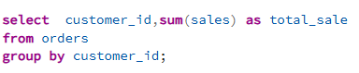
This query calculates how much total revenue each customer has generated for the business.

- Find the top 5 customers by total sales.
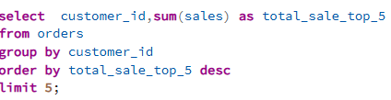
This query identifies the top 5 customers who generated the highest revenue.
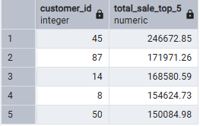

- Find the customer who placed the most orders.
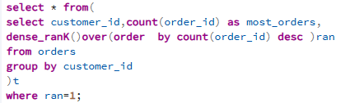
This query identifies which customer has placed the highest number of orders using ranking.
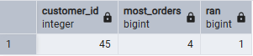

- Find customers whose total sales are above average customer sales.
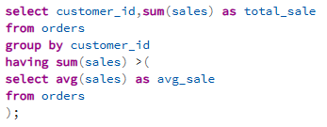
This query identifies customers whose total sales are higher than the average sales of all customers.

- Show each customer with the number of products they purchased
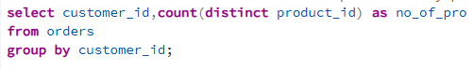
This query shows how many different products each customer has purchased.
5.Product Analysis
- Show total revenue generated by each product.
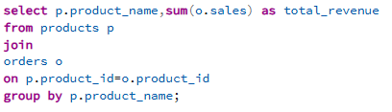
This query calculates how much revenue each product generated.
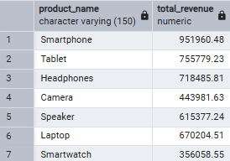

- Find the top 5 best selling products
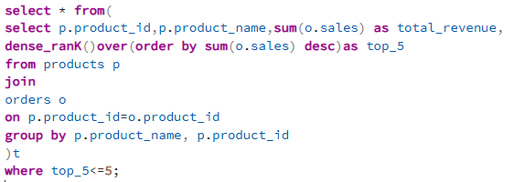
This query ranks products and shows top 5 products based on sales.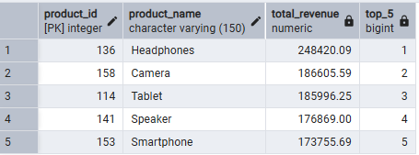

- Find the product with the highest total sales.
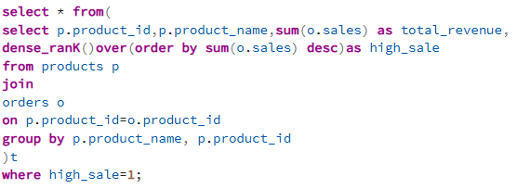
This query finds the product that generated the highest revenue.
- Rank products based on total revenue.
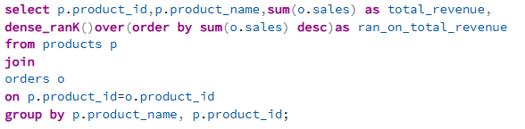
This query assigns rank to each product based on total revenue using a window function.

- Find products that were ordered more than 10 times.
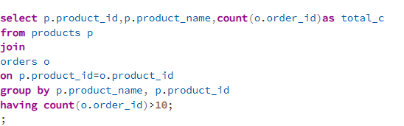
This query finds products that were frequently purchased (more than 10 times).

6.City Analysis

- Show total sales by city.
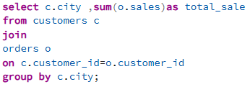
This query calculates total revenue generated from each city.
- Find the city with the highest revenue.
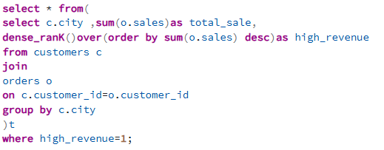
This query Show city with the highest revenue.
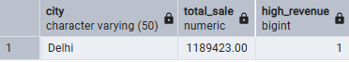

- Find the average sales per order in each city.
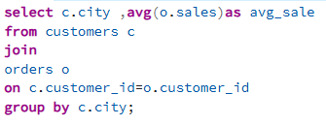
This query Find the average sales per order in each city.

7. Time-Based Sales Analysis
- Show total sales per month.
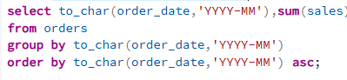
This query calculates total sales for each month. It helps identify sales trends over time.

- Find the month with the highest revenue.
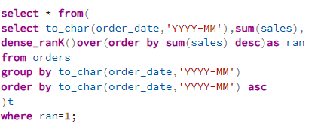
This query finds the month in which the business earned the highest revenue.
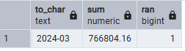

- Calculate running total sales by order date.
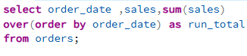
This query calculates cumulative sales over time using a window function.
8.Window Function Analysis
- Rank orders by sales.
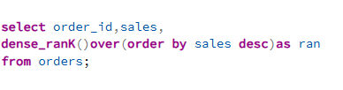
This query ranks all orders based on sales value.

- Show each order with the previous order's sales for the same customer.
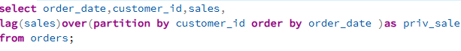
This query Show each order with the previous order's sales for the same customer.
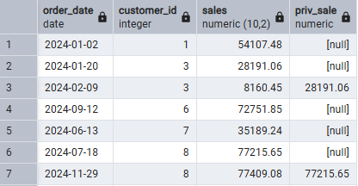

- Find orders where sales increased compared to the previous order.
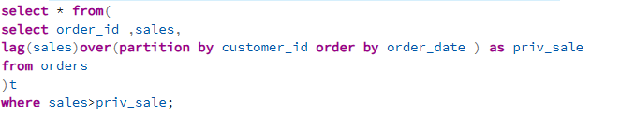
This query Find orders where sales increased compared to the previous order.

- Show each order with the difference between its sales and average sales.
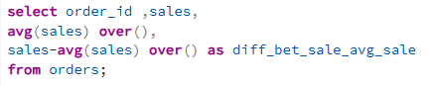
This query Show each order with the difference between its sales and average sales.

- Find customers who bought more than one product category. 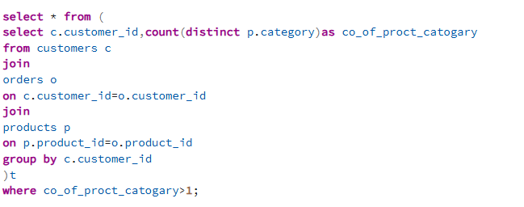
This query Find customers who bought more than one product category.

- Find the percentage contribution of each product to total sales.
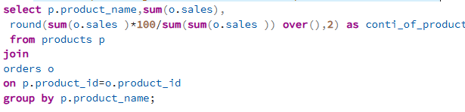
This query Find the percentage contribution of each product to total sales.

- show the top product purchased by each customer.
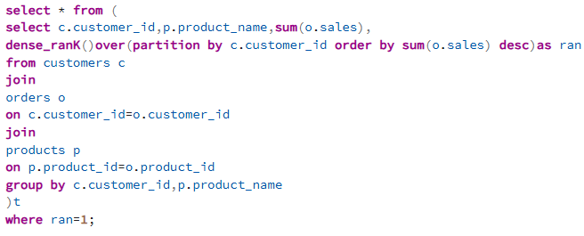
This query show the top product purchased by each customer.

- Find customers whose first order sales were lower than their last order sales.
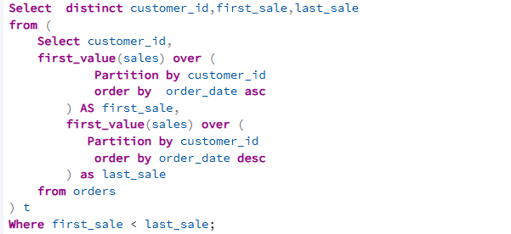
This query Find customers whose first order sales were lower than their last order sales.

- Find the second highest sale in the entire dataset.
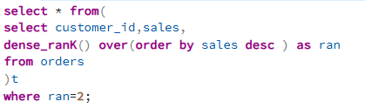
This query Find the second highest sale in the entire dataset.
9. Key Insights
From the analysis, the following insights were discovered:

- A small group of customers contributes significantly to total revenue.
- Certain products generate much higher revenue compared to others.
- Sales performance varies across different cities.
- Monthly sales trends help identify peak business periods.
- Window functions provide deeper analytical capabilities for ranking and trend analysis.
10.Conclusion
This project demonstrates how SQL can be used effectively for business data analysis. By using PostgreSQL and pgAdmin, various SQL techniques such as joins, aggregations, grouping, and window functions were applied to extract valuable insights from sales data.

The project highlights the importance of SQL in analyzing customer behavior, product performance, and sales trends. Such analysis can help organizations make better data-driven decisions and improve their overall business strategy.
11. Skills Used
- SQL Joins (INNER JOIN) to combine multiple tables
- Aggregate Functions (SUM, COUNT, AVG) for data analysis
- GROUP BY and HAVING for grouping and filtering data
- Subqueries for advanced filtering and comparisons
- Window Functions (RANK, DENSE_RANK, LAG, FIRST_VALUE)
- Data Analysis and Business Insights Generation
- Date Functions for time-based analysis
- PostgreSQL for database management

